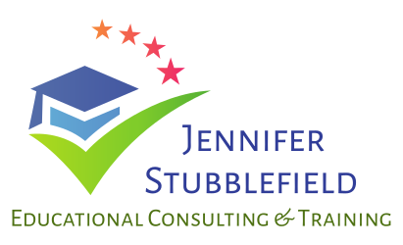
Testimonials & Take-a-Ways

- “High energy, enthusiastic, well prepared. She managed a large group with ease. Great presentation with very useful ideas.” – MOS Boot Camp, 2017
- “Loved this session-it alone was worth coming to the entire conference. She motivates me to be a better teacher.” – MOS Boot Camp, 2017
- “Jennifer was excellent, her vibrant personality makes her a phenomenal motivator for teachers. Gave out so many of her personal files and activities that can be used in my classroom.” – MOS Boot Camp, 2017
- “Jennifer brought a level of energy to the room that I have never seen a presenter do before. First teacher PD I have attended in a while that was actually fun and so worthwhile.” – Putting the Pep Back in your MOS Step, 2018
- “Love the techniques/methods that she not only told us about but that she also modeled for us as we became her ‘class.’ Can’t wait to take this back to my district to show my co-teachers.” – Putting the Pep Back in your MOS Step, 2018.
- “She is very knowledgeable and seemed to make a true effort to customize the lesson to our industry. She was so patient when we messed up!” – Excel Training, Paducah Board of Realtors, 2018
- “Jennifer managed to probably cut an hour off of my daily tasks…I can’t believe I have been wasting so much time. She was so good I didn’t even want to take my bathroom break during the session!” – Excel Training, Paducah Board of Realtors, 2018
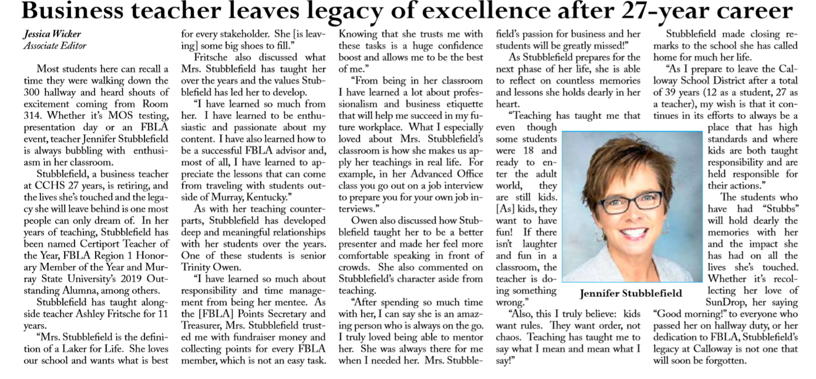

2019 Most Outstanding Alumni-Murray State University

Soft Skills Video Course Author

